Chapter 4, Problem 72.

- For the circuit in Fig. 4.138, obtain the Thevenin equivalent at terminals a-b.
- Calculate the current in R_{L} = 8Ω.
- Find R_{L} for maximum power deliverable to R_{L}.
- Determine that maximum power.

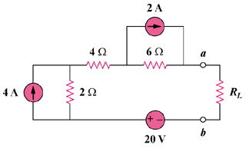

Figure 4.138
For Prob. 4.72.

